IICT FINAL PROJECT REPORT
GROUP MEMBERS:
SUNAINA AFTAB
IFRAH FAROOQ
ZOHA

1. Introduction
GlamAura is a static makeup and beauty website developed using HTML and CSS. The website is designed to showcase different beauty products such as lipsticks, foundations, eyeshadows, and makeup tools. The main purpose of this project is to understand basic web development concepts including page structure, styling, layout design, and responsiveness. This project helped us gain practical experience in creating visually appealing and user-friendly web pages .

2. Scope
The scope of the GlamAura website is limited to front-end development only. The website provides:
- A homepage with brand introduction
- Product listing section
- About Us page
- Contact form (non-functional)
The website does not include backend functionality, database, or dynamic features. It focuses mainly on design, layout, navigation, and responsiveness.

3. Requirements

Software Requirements
- Visual Studio Code / Notepad++
- Google Chrome / Microsoft Edge
- Canva (for design inspiration)

Languages Used
- HTML
- CSS

Hardware Requirements
- Computer/Laptop
- Internet connection (for resources and images)

4. Design / Methodology
The website was designed using HTML elements and styled using CSS.

HTML Design
- Header section for logo and navigation bar
- Sections for products, about, and contact
- Footer for copyright information

CSS Design
- Flexbox used for layout
- Color themes matching makeup aesthetics
- Responsive design using media queries

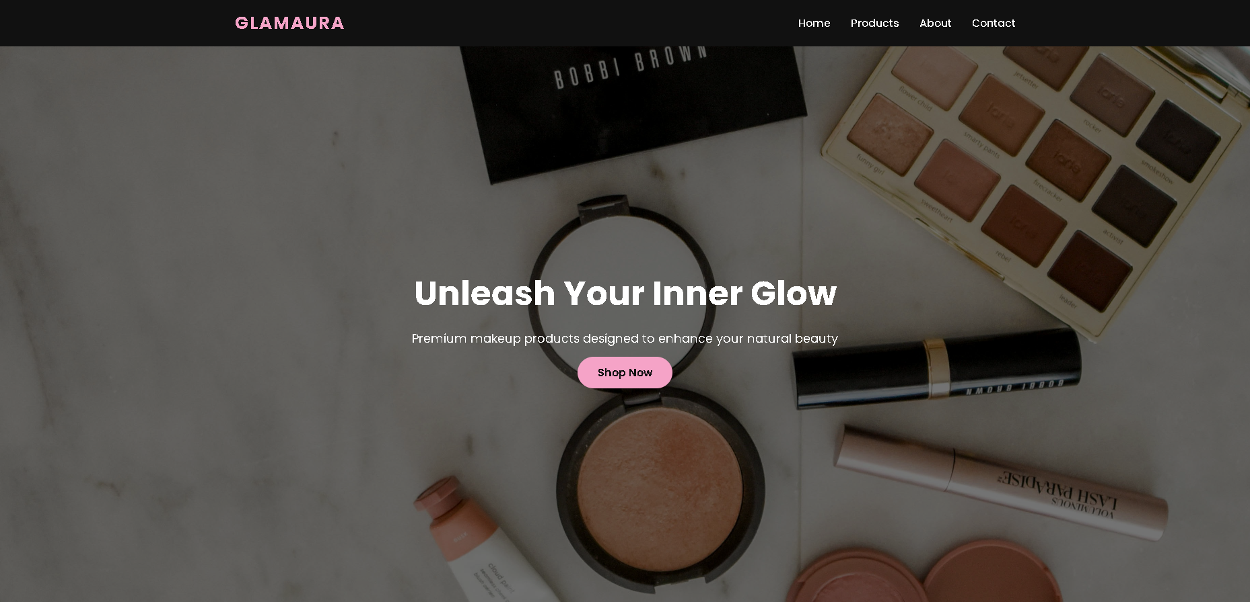
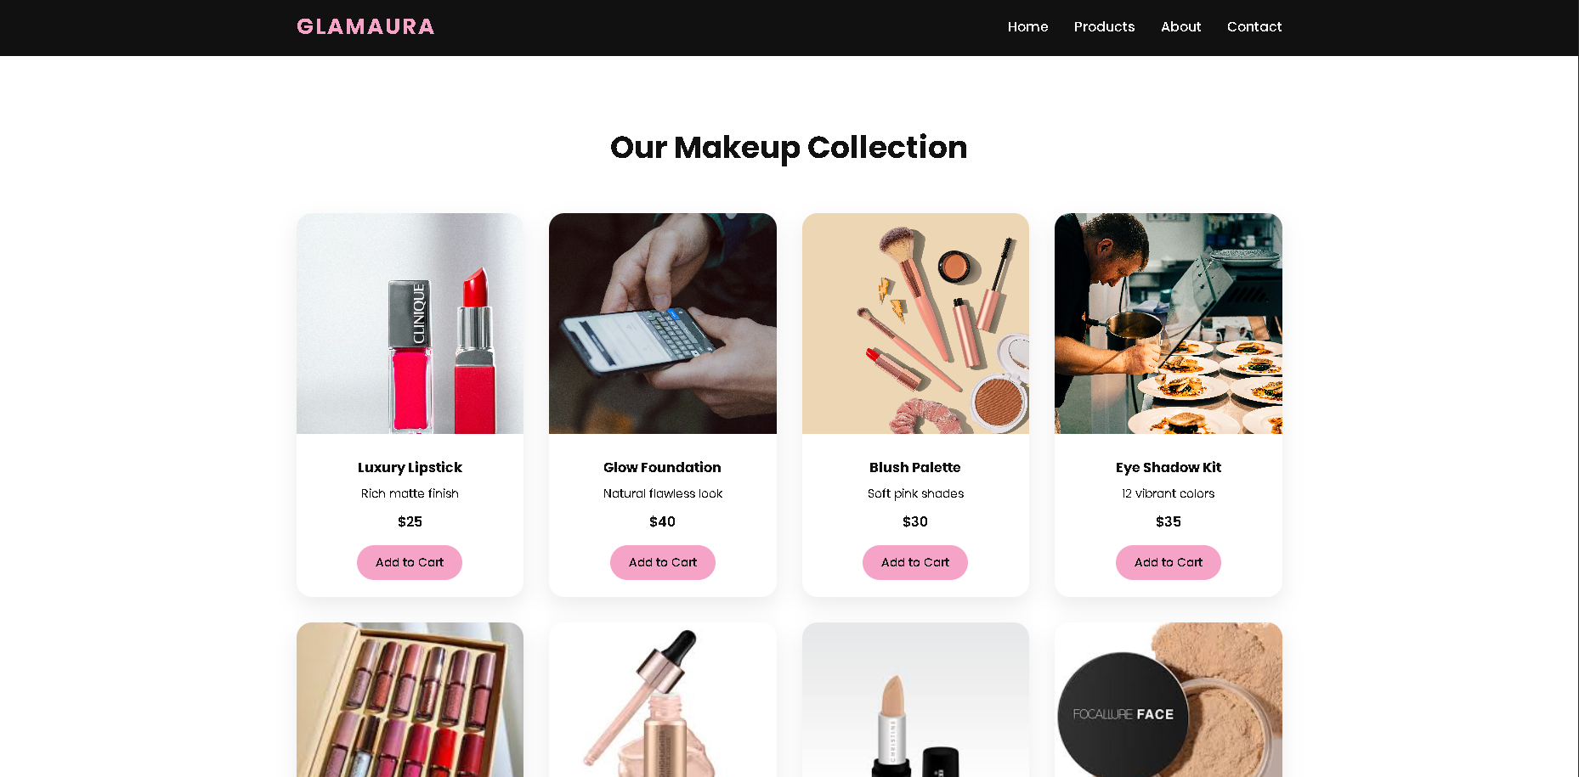

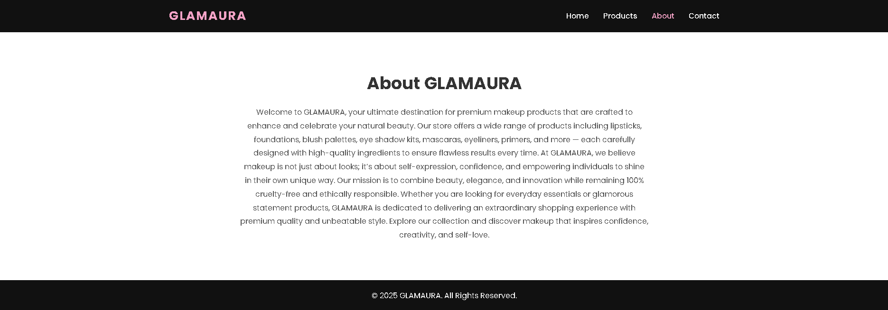
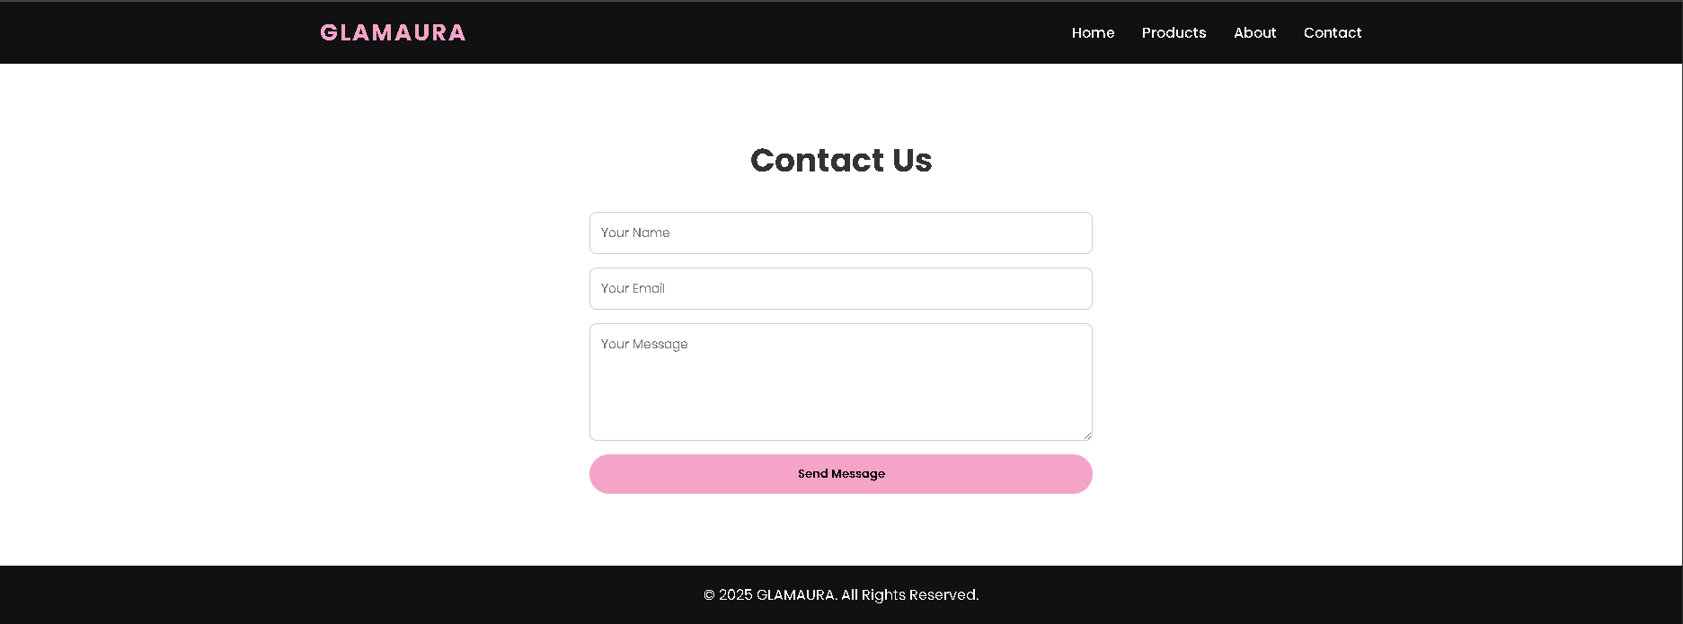

5. Gantt Chart
A Gantt chart was created to plan and track the progress of the project. It includes:
- Requirement analysis
- Design phase
- Development phase
- Testing
- Final submission

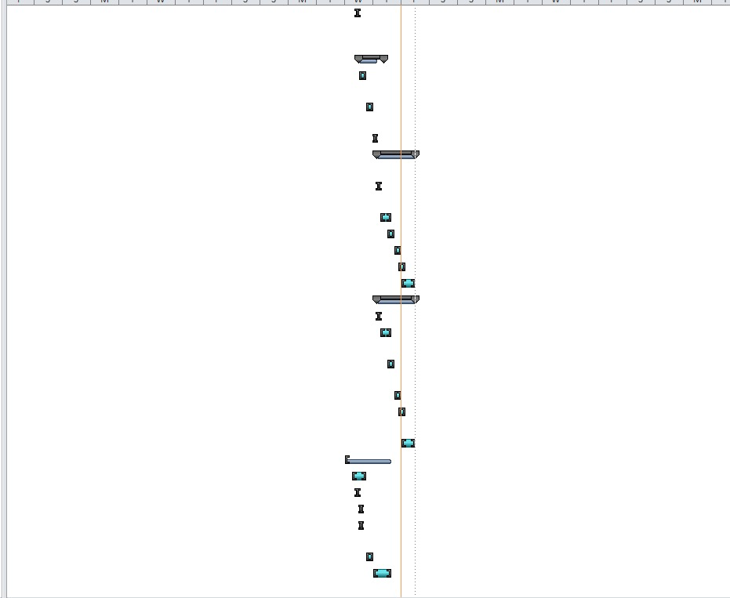

6. MS Project Screenshot
MS Project was used to manage project tasks and timelines efficiently.
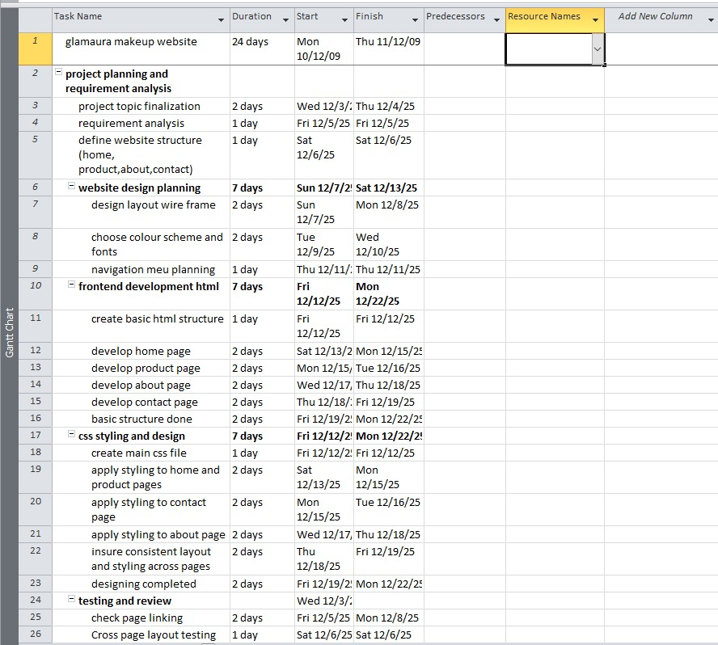
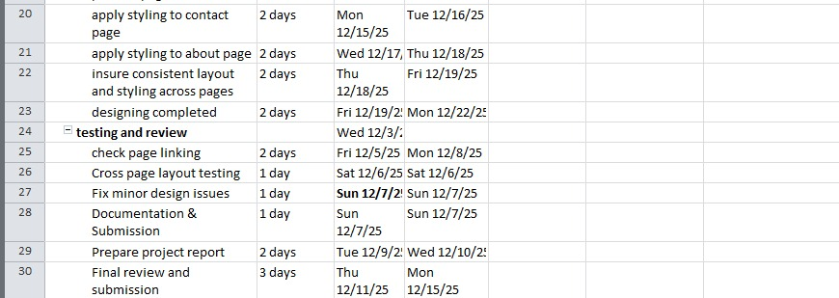

7. Code Screenshots
This section includes screenshots of:
- HTML files (index.html, products.html, contact.html)
- CSS file (style.css)
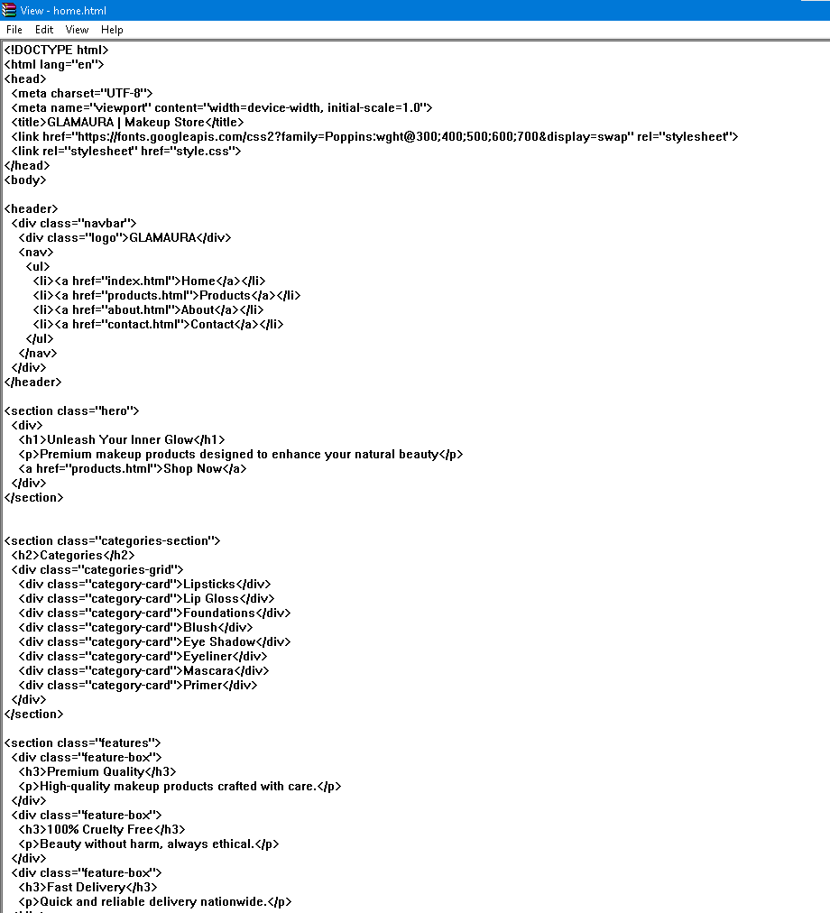
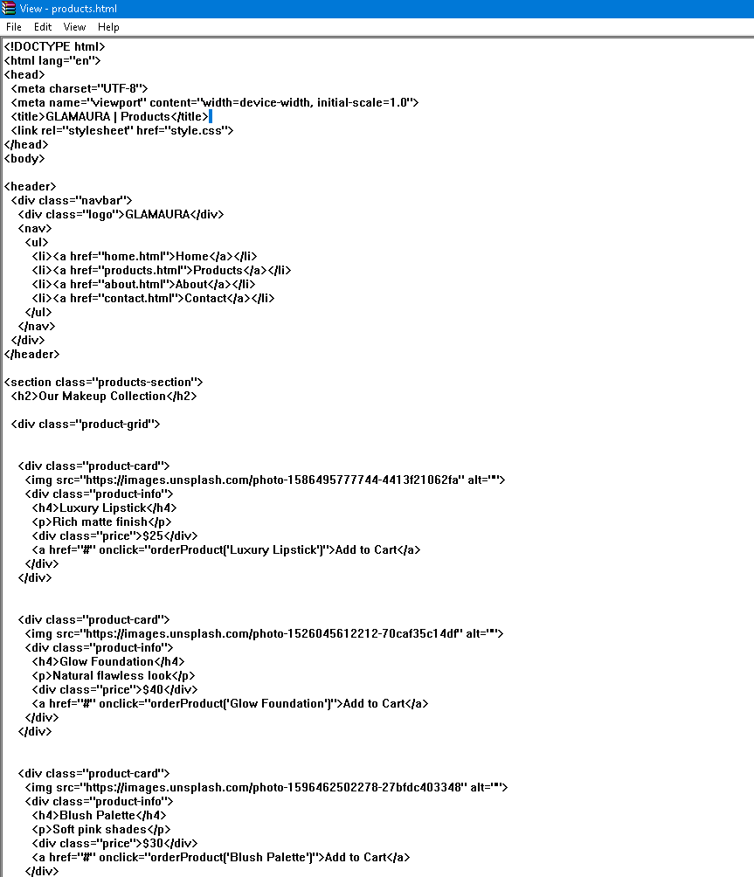

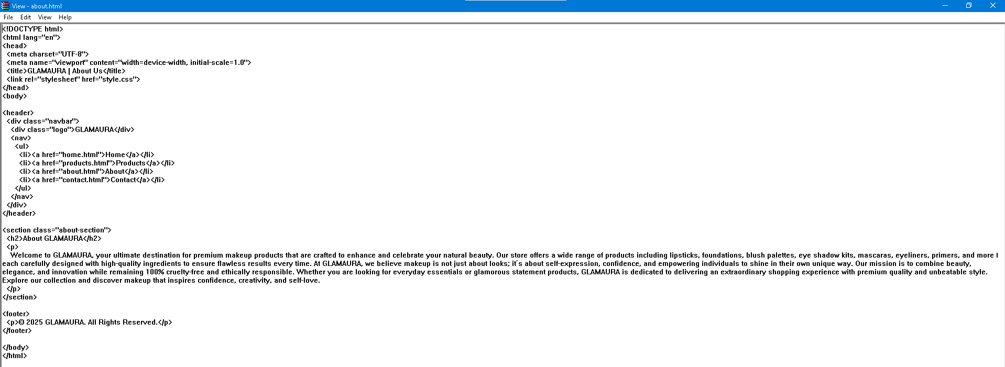
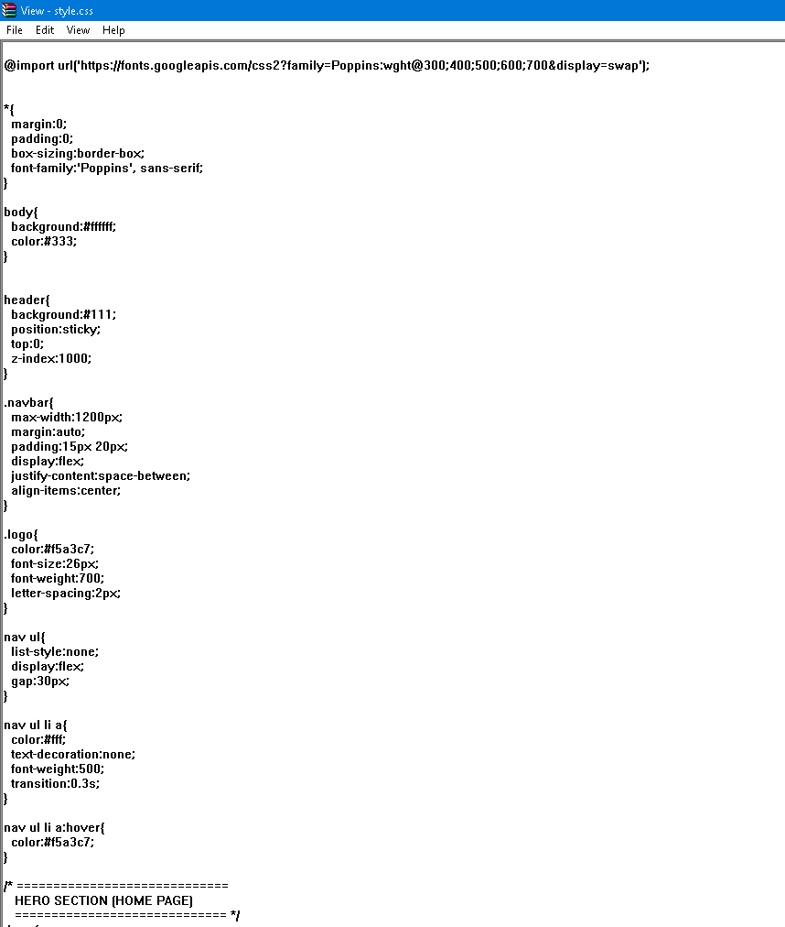

8. Conclusion
The GlamAura project successfully achieved its objectives of creating a simple and elegant makeup website using HTML and CSS. Through this project, we learned how to structure web pages, apply styling techniques, and design responsive layouts. This project enhanced our understanding of front-end web development and provided a strong foundation for future projects involving advanced technologies

